When turning in to the Benton clinic (located at 618 N. Benton Springfield, MO 65806) you’ll see several parking options. Please do NOT park in the front (west) or side (south) of the clinic, we reserve those spots for our patients. You can park in the church parking lot to the right (south) of the clinic.

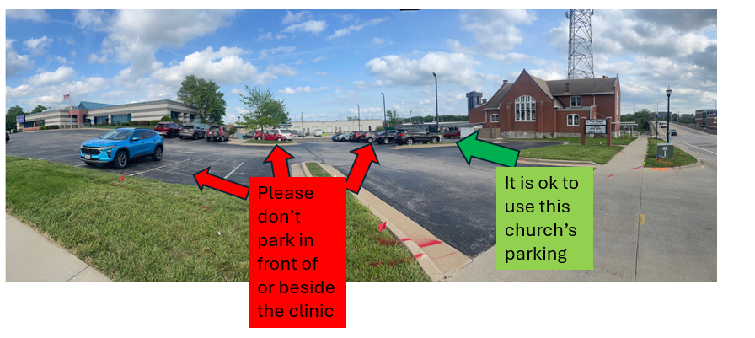
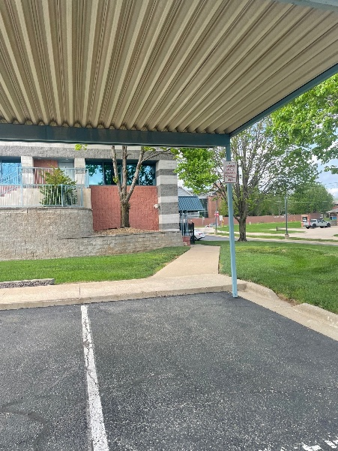
To enter the Billy Long Medical and Dental Training Center please walk to the back (east) side of the building.

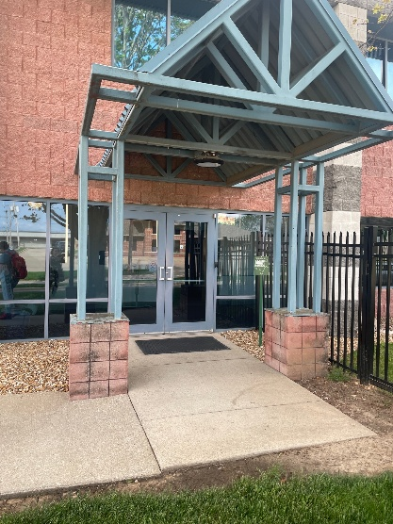

You’ll enter using the east-most set of doors. These are badge-access only, but, there will be staff present to let you in.

